INCIDENT AND INJURY REPORT FORM
Instructions: Please complete Parts A and C (if incident has occurred), or Parts B and C (if injury has occurred), within 24 hours of the event occurring, and forward to Principal Solicitor immediately.
Please attach extra sheets if you require more on this form.
Part A: Details of incident (eg property, plant or environmental damage)
Date of incident |  | Time of incident
Nature of incident | - Physical assault  - Verbal assault  - Slip and/or trip  - Self-harm  - Near miss (i.e. incident nearly occurred and could be prevented in the future)  - Left premises  - Medical condition  - Other
Location of incident
Description of incident
Name of person who received the report |  | Telephone
Reported to authorities, if appropriate? | Yes Provide details (when and whom):  No
Part B: Details of injury (e.g. to a staff member or consumer client) and treatment
Date of incident |  | Time of incident |  | am pm
Name of injured person |  | Date of birth
Exact site location where injury occurred |  | Telephone
Activity in which the person was engaged at the time of injury | (e.g. during a visit, in a break, in the office)
Nature of injury | - Sprain / strain  - Open wound  - Fracture  - Bruising (contusion) or crushing  - Burn  - Psychological injury (e.g. from aggression or harassment)  - Slip, trip or fall  - Object in the eye  - Choking  - Near miss (i.e. an injury that nearly occurred and could be prevented in the future)  Other: ________________________________________________________________________________________________________________________________________________________________________________________________________________________________________________________________________________________________________________________________________________________________________________________________________________________
Body location of injury if physical (indicate location of injury on the diagram) | 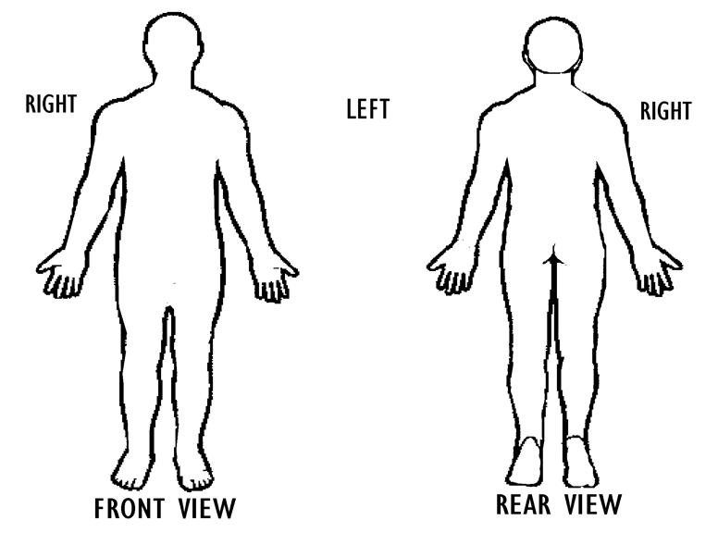
Treatment given on site |  | Name of treating person
Referral for further treatment? | Yes Name of doctor or hospital:  No | Medical certificate received? | Yes  Attach copies  No

Injury management required? |  |  | Yes Notify return to work coordinator  No |  | Name of return to work coordinator
Reported to authorities |  |  | Yes Provide details (when and whom):  No
Witness to event (each witness may be contacted to provide an account of what happened)
Witness name |  |  |  | Witness phone number
Part C: Investigation
Cause of incident or injury
Completed by
Name |  |  |  |  |  | Position
Signature |  |  |  |  |  | Date
Preventative actions (include what needs to be done, who will do it and when it will be done)
Completed by
Name |  |  |  |  |  | Position
Signature |  |  |  |  |  | Date
Manager’sSignature |  |  |  |  |  | Date

Any further comments:______________________________________________________________________________________________________________________________________________________________________________________________________________________________________________________________________________________________________________________________________________________________________________________________________________________________________________________________________________________________________________________

NB: Please ensure a copy or the original report is forwarded to the Office manager to be logged and filed into the Street Law Centre Incident Records File.

